From: http://davidstockmanscontracorner.com/peak-trump-the-swamp-creatures-cohendavis-offensive/

Peak Trump: The Swamp Creatures' Cohen/Davis Offensive
By David Stockman. Posted On Wednesday, August 22nd, 2018
You can't find a bigger beltway scumbag and Clinton bagman than Lanny Davis. But Michael Cohen did find him---so now the overt campaign to eject the Donald from his Oval Office redoubt begins in earnest.
The fact that it is being quarterbacked by Lanny Davis tells you all you need to know. He represents the politburo of the Deep State and the very Clintonista establishment that attempted to deep six the Donald's candidacy in the first place via pre-election leaks from their phony (and illegal) Russia-collusion investigation.
Worse still, when it comes to the pot calling the kettle black it doesn't get more ludicrous than Lanny Davis coaching Cohen on how to compose about Trump's hush payments to his bimbos. For crying out loud, Davis was Bill Clinton's #1 defender and round-the-clock media surrogate during the Monica Lewinsky affair.
Even when Bawdy Bill confessed to schtupping Monica in the Oval Office, Davis was a one-man whirligig of spin, as per this September 1998 story from the Washington Post:
Lanny Davis is inescapable these days. He's live on "Rivera Live" and "Larry King Live," crossing swords on "Crossfire," showing up on "The Big Show" and the Sunday shows, the man who soldiers on in Clinton's defense when no one else will report for duty. On Aug. 17, the day the president admitted misleading the country about his affair with Lewinsky, Davis blabbed away on NBC and MSNBC and CNBC from morning till night. He refused a $2,500 payment, directing it to his wife's favorite cause, a newsletter for pet adoption.
He's become a minor celebrity, with people stopping him in airports. Some friends -- including the reporters he assiduously courted as a Clinton aide -- say he's having the time of his life. Davis's not inconsiderable ego loves the limelight.
But Davis' shameless shilling for Bill Clinton was par for the course-----the essence of his entire 50-year sojourn in the Imperial City as a fixer, spinner, racketeer and concierge to the high and mighty.
During that span he was a law school chum of the Clintons, perennial advisor to Dem pols, omnipresent MSM talking head, beltway PR flack for hire, lead-apologist for Bill Clinton's tawdry Lewinsky affair, and lifetime shill for foreign and domestic special interests in the guise of that special brand of "law" practiced on K-street.
Needless to say, Davis has never earned an honest dollar in his life; and his smug, opinionated elitism has never graced the halls of anything that remotely resembles a productive capitalist enterprise.
In a word, you can't find a more contemptible Swamp Creature than Lanny Davis. It's as if the very fetid pools of corruption which underlie the Imperial City mustered up their own designated hitter to take the fight right to the Donald's front door.
In fact, the new Davis/Cohen tag team amounts to still another vector in the Deep State's unremitting campaign to re-litigate the 2016 election. From the very moment the race was called for Trump in the wee hours of November 9, Davis had been conducting a nonstop campaign claiming that Hillary was the real winner---save for the Comey stab in the back on October 28 and the nefarious Russian campaign to swing the outcome to Trump.
Indeed, Davis' greasy head as been buried so long between Hillary's withered bosoms that he recently wrote to her the following encomium:
“The honest to goodness truth is … aside from Carolyn, my four children, and my immediate family, I consider you to be the best friend and the best person I have met in my long life.”
So Trump's fixer is now in league with Hillary's devout manservant. You can't say the Deep State isn't resourceful.

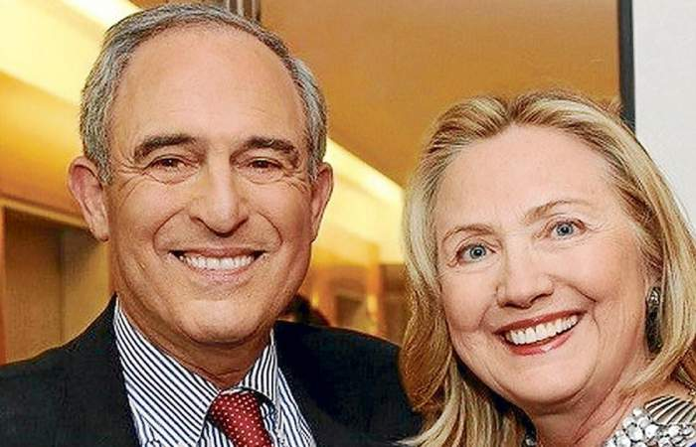
Needless to say, Cohen's indiscretions with respect to filling out loan applications and faithfully reporting to Uncle Sam his income from his taxi cab ventures and brokering of Birkin bags amount to petty crimes at best, which are neither here nor there when it comes to the Donald's alleged perfidies.
More importantly, by the lights of many legal experts, including the renowned and fair-minded Alan Dershowitz, paying hush money does not necessarily violate the campaign laws if the candidate provided the money himself, which the Donald actually did:
Further, Spakovsky said "a candidate can spend as much of their own money as they want to—even if it was a campaign-related expense.”
Harvard Law professor emeritus Alan Dershowitz, a frequent defender of the president, made a similar argument.
“You have to show that it’s a crime,” he told “Fox & Friends.” He said it’s “not a crime” for a candidate like Trump to contribute to his own campaign, and probably not even a crime to direct someone else to contribute if he plans to pay that back.
Further, Dershowitz said, “The only evidence that the president did anything that might be unlawful … comes from a man who’s admitted to be a liar.”
But Davis is up to something far bigger than getting Cohen to sing about the hush money---that debatable crime is just the pretext. What's really coming down the pike is that Davis has Cohen primed to compose new fibs and lies about the Russia collusion hoax.
That much was evident in Davis' out-of-the box interview with the tinfoil-hatted queen of anti-Russkie hysteria, Rachel Maddow:
"Mr. Cohen has knowledge on certain subjects that should be of interest to the special counsel and is more than happy to tell the special counsel all that he knows," Davis told MSNBC on Tuesday.
"Not just about the obvious possibility of a conspiracy to collude and corrupt the American democracy system in the 2016 election, which the Trump Tower meeting was all about, but also knowledge about the computer crime of hacking and whether or not Mr. Trump knew ahead of time about that crime and even cheered it on.”
Davis then delivered the punch line of his entire Michael Cohen gambit:
"it looks to me like abuse of power which is essential for impeachment."
There you have it. Lanny Davis' Clinton patrons have extracted hundreds of millions from foreign special pleaders and fraudsters in their endless influence peddling schemes at the highest levels of government, but the Donald is supposedly ripe for impeachment because, why?
Because he legally ordered $230,000 be sent to two sleazy blackmail artists who more than a decade ago apparently volunteered to line his bed sheets.
To be sure, we don't know who was stupider----the Donald for capitulating to their threats, since the world already knew by October 2016 that he was an all-time womanizing sleazeball; or the porn star and Playboy model who fell for a self-promoting New York windbag, as it happened, that didn't have much to offer in either the business or pleasure departments anyway.
So if you want to know why the Swamp is so fetid, just consider where Davis is actually taking his Michael Cohen scam. That is, he's actually got the nerve to attempt to morph Donald Trump's low-life fixer into a heroic truth teller deserving of an outpouring of financial support from concerned American citizens!
You can't make this stuff up. Davis completed his day of media rounds with a plea for money from a crowd-funded scam called the "Michael Cohen Truth Fund":
In order to get Michael to be able to help, we need help on this fund, MichaelCohenTruthFund.com, we ask everybody to help Michael Cohen tell the truth about Donald Trump."
Even then, it gets worse. It was the single high-point of Trump's presidency---his courageous summit meeting with Putin to repudiate Washington's dangerous and unwarranted vilification of Russia---that allegedly brought the red-white-and-blue blood of patriotic outrage oozing from Cohen's nostrils.
But what unadulterated hog swill.
The faux outrage described below does not come from a rough-and-tumble striver up from the town of Lawrence on Long Island; it's actually the mark of the Deep State ruling class that is so desperate for an enemy in order to keep its $800 billion per year national security gravy train going that it would actually violate the sanctity of America's electoral process to prevent a rapprochement with Russia.
Playing the "remorseful criminal" card, Davis also told MSNBC that it was Trump’s meeting with Russian President Vladimir Putin in Helsinki that marked "a significant turning point” for Cohen and encouraged him to come forward out of concern about the U.S. future. "That shook up Mr. Cohen" who may be a tax-evading criminal but is first and foremost a patriot.
We don't profess to know exactly how this new Davis/Cohen offensive will play-out in the months ahead, but the objective is abundantly clear. That is, to breathe life back into the faltering Russian Collusion Hoax, and give Mueller some fresh fodder for his upcoming Impeachment Report.
If the mid-term elections were hanging in the balance between a Blue Wave of Dem congressional control or a Blue Ripple cliffhanger that saves the GOP majorities, the odds have now increased measurably in favor of the former. Either way, Washington is now descending into a swamp of vicious civil war that has not been witnessed since, well, the actual Civil War.
And in that context, we do not expect the Donald to take this latest Deep State offensive sitting down. He's already unhinged, delusional and writhing with bile, bombast and bunkum.
Accordingly,
- his misbegotten Trade War will get more fraught,
- his attacks on the Fed more wanton and
- his disregard for the unfolding fiscal calamity more blatant.
By any rational measure that makes the Donald travails a clear and present danger to the egregious bubble sitting at the tippy-top of the casino's "record" 3,453 day bull run.
Indeed, they are a dagger pointed at the very heart of it because there is absolutely no way for a bedraggled 111-month old faltering recovery to survive the quadruple threat of an inflationary Trade War, a normalizing Fed, a hemorrhaging fiscal equation and an unconstitutional attempt to remove a sitting President.
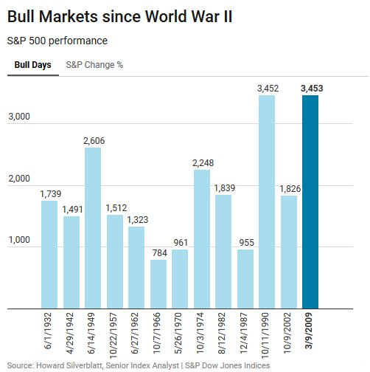
Except, except.
Wall Street does not even remotely see the Great Financial Crisis 2.0 barreling down the pike. It has literally become so inebriated by years and decades of Bubble Finance that it can no longer tell the difference between a weak or strong economy; or realize that 95% of Q2's vaunted earnings growth was nothing more than the one-time impact of the tax cut and the rebound from the 2015-2016 earnings swoon.
Indeed, four years ago LTM earnings on the S&P 500 came in at $106 per share in September 2014 compared to $117 per share for the June 2018 LTM period when adjusted for the tax change. That's a gain of just 2.5% per annum---and it's no boom by any conceivable definition of the word.
Nevertheless, right on signal MarketWatch today assured that none of yesterday's Trumpian contretemps matter---- except booming earnings and robust economic growth, whether they actually exist or not:
Corporate earnings and the economy still carry more weight with investors than President Donald Trump’s mounting legal woes.
While the latest turn appeared to boost the threat of impeachment, investors remained focused on an economy that’s growing at an annualized clip of near 4%, while the unemployment rate stands at less than 4%, said Greg Valliere, chief global strategist at Horizon Investments, in a note.
“If the trade wars cool off a little this fall, we still think stocks can grind higher,” he said. “It’s not a pretty picture here in Washington, but as long as Trump doesn’t go totally off the rails, investors can compartmentalize.”
Alas, here again is the litmus test---the quarterly GDP at seasonally maladjusted rates since 2011.
There is absolutely no Trumpian Boom about it---most especially when you recall that 100 basis points of the 4.1% bar for Q2 was owing to Trade War pull forwards on the export accounts and another 100 basis points was owing to a one-time consumer spend-out of tax cuts funded on Uncle Sam's tapped out credit card.
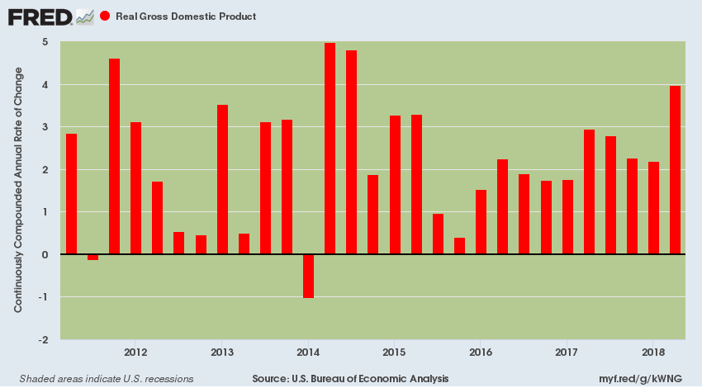
So Peak Trump is truly at hand. When the Wall Street bubble finally bursts there will be blood on both ends of the Acela Corridor like never before.

